Basic Verifiable Education Credential

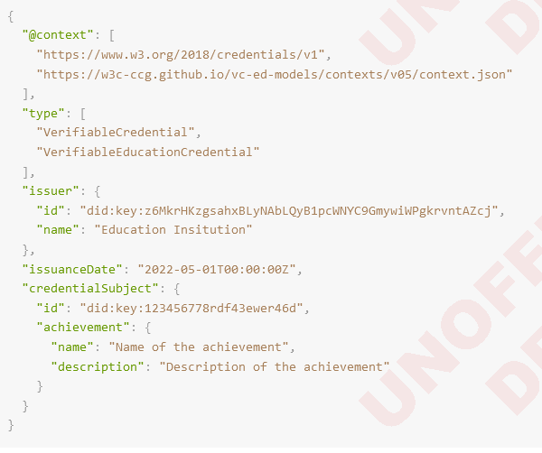

Explanation of data model

* Contexts (used in same sense as in VC-Data-Model)
* first and second item are URIs
* ID (used in same sense as in VC-Data-Model)
* Unique identifier for VC
* Not always included
* URI or URL
* Type (used in same sense as in VC-Data-Model)
* Map to the context
* Issuer (used in the same sense as in VC-Data-Model)
* DID of the institution and name of the institution
* Issuance Date (used in same sense as in VC-Data-Model)
* Credential subject (used in same sense as in VC-Data-Model)
* Contains properties related to the credential subject (such as DID and achievement’s name and description)

Diploma Issued as an Open BadgeEin Bild, das Text enthält.

* Additional information, such as name of Open Badge Instance, issuer type, and additional credential subject properties

<https://w3c-ccg.github.io/vc-ed-use-cases/>

<https://w3c-ccg.github.io/vc-ed-models/>

<https://www.w3.org/TR/vc-data-model/>